SIMATS ENGINEERING
ASSESSMENT TOOL 1: Expert System Development Project
COURSE NAME: | ARTIFICIAL INTELLIGENCE AND EXPERT SYSTEMS | COURSE CODE: | MLA01

COURSE OUTCOME COVERED
CO 5: Construct rule-based expert systems using production rules, forward and backward chaining, and by distinguishing procedural and non-procedural paradigms across development stages.(BTL 3)
Assessment Tool Weightage: 40%
Total Marks: 100 Time: 90 Mins
No. of Questions: 1
Annexure A
Expert System Development Project

Code of Conduct:
I Mokshitha Kilari (192525413) (Name / Reg No) certify that this submission is my original work and that I have adhered to the guidelines specified for this assessment.
I understand that any violation of academic integrity rules will result in disciplinary action.
Signature of the student: MOKSHITHAKILARI

Criterion | Weightage | Marks Obtained
1. Problem Analysis and Domain Understanding | 10%
2. Knowledge Acquisition and Knowledge Representation | 10%
3. Production Rule / Knowledge Base Design | 15%
4. Prolog Implementation and Programming | 15%
5. Forward Chaining Implementation and Demonstration | 10%
6. Backward Chaining Implementation and Demonstration | 10%
7. Procedural and Non-Procedural Paradigm Analysis | 10%
8. Unification, Backtracking and Inference Accuracy | 10%
9. Testing, Results and System Demonstration | 5%
10. Documentation, GitHub Repository and Technical Presentation | 5%
Total | 100%

Signature of the Faculty Total Marks Awarded

ANSWER ANY ONE OF THE FOLLOWING
Tool: SWI-Prolog
Usage of Prolog: Students shall use Prolog to develop a rule-based expert system by representing domain knowledge as facts and production rules, and implementing reasoning through forward and backward chaining. The project should demonstrate Prolog's declarative/non-procedural nature, logical inference, rule matching, and automated conclusion generation.
S.No. | Scenario-Based Expert System Development Question
1 | Medical Diagnosis Expert System:  Develop a rule-based expert system that identifies possible diseases based on symptoms, patient observations, and basic clinical information. Represent domain knowledge using production rules and implement both forward and backward chaining to derive conclusions.
2 | Crop Disease Advisory System:  Develop an expert system that identifies possible crop diseases based on leaf symptoms, soil conditions, weather conditions, and visible plant characteristics. Construct suitable production rules and demonstrate diagnosis using forward and backward chaining.
3 | Automobile Fault Diagnosis System:  Design an expert system that identifies probable vehicle faults based on symptoms such as engine noise, starting problems, warning indicators, abnormal vibration, and reduced mileage. Implement the knowledge base using production rules and compare forward and backward reasoning.
4 | Student Academic Advisory System:  Develop an expert system that recommends suitable academic interventions based on attendance, internal marks, assignment performance, learning difficulties, and previous academic performance. Use production rules and demonstrate both forward and backward chaining.
5 | Cybersecurity Threat Diagnosis System:  Construct a rule-based expert system that identifies possible cybersecurity threats from events such as repeated login failures, unusual network traffic, suspicious file activity, and unauthorized access attempts. Implement production rules and demonstrate how forward and backward chaining arrive at a threat classification.

Report Format:

Stage | Student Activity | Expected Output
1. Domain Analysis | Identify the problem domain, entities, facts, symptoms/conditions, and possible conclusions. | Problem definition and domain model
2. Knowledge Acquisition | Collect domain knowledge from reliable sources or domain experts. | Knowledge specification
3. Knowledge Representation | Convert domain knowledge into IF–THEN production rules. | Knowledge base
4. Inference Design | Implement forward chaining and backward chaining. | Inference engine
5. Paradigm Analysis | Distinguish how the solution can be expressed using procedural and non-procedural approaches. | Paradigm comparison
6. System Development | Integrate the knowledge base, inference engine, user interface, and explanation facility. | Working expert system
7. Testing | Test the system using multiple facts and scenarios. | Test cases and outputs
8. Evaluation | Analyze correctness, coverage, consistency, and reasoning performance. | Evaluation results
9. Documentation | Prepare technical documentation and GitHub repository. | Project report + GitHub
10. Demonstration | Demonstrate the system and explain the reasoning process. | Project presentation/viva

Selected Scenario-Based Question
Question 4 – Student Academic Advisory System
Develop an expert system that recommends suitable academic interventions based on attendance, internal marks, assignment performance, learning difficulties, and previous academic performance. Use production rules and demonstrate both forward and backward chaining.

1. Domain Analysis
Problem definition: The system acts as an academic advisory expert that converts observable student performance information into explainable risk classifications and recommended interventions. It is not intended to replace a faculty member; it provides a consistent first-level advisory decision.
Domain entities: Student, attendance percentage, internal assessment percentage, assignment performance percentage, learning difficulty indicator, previous academic performance indicator, academic risks, and interventions.
Initial facts used for demonstration: Mokshitha has 68% attendance, 42% internal marks, 45% assignment performance, reports a learning difficulty, and has previous poor academic performance.
Possible conclusions: attendance risk, academic risk, assignment risk, learning support needed, previous-performance risk, at-risk status, remedial classes, attendance counselling, faculty mentoring, individualized study plan, and priority intervention.
Goal: derive recommendations from facts using a transparent rule base, while showing both data-driven and goal-driven reasoning.
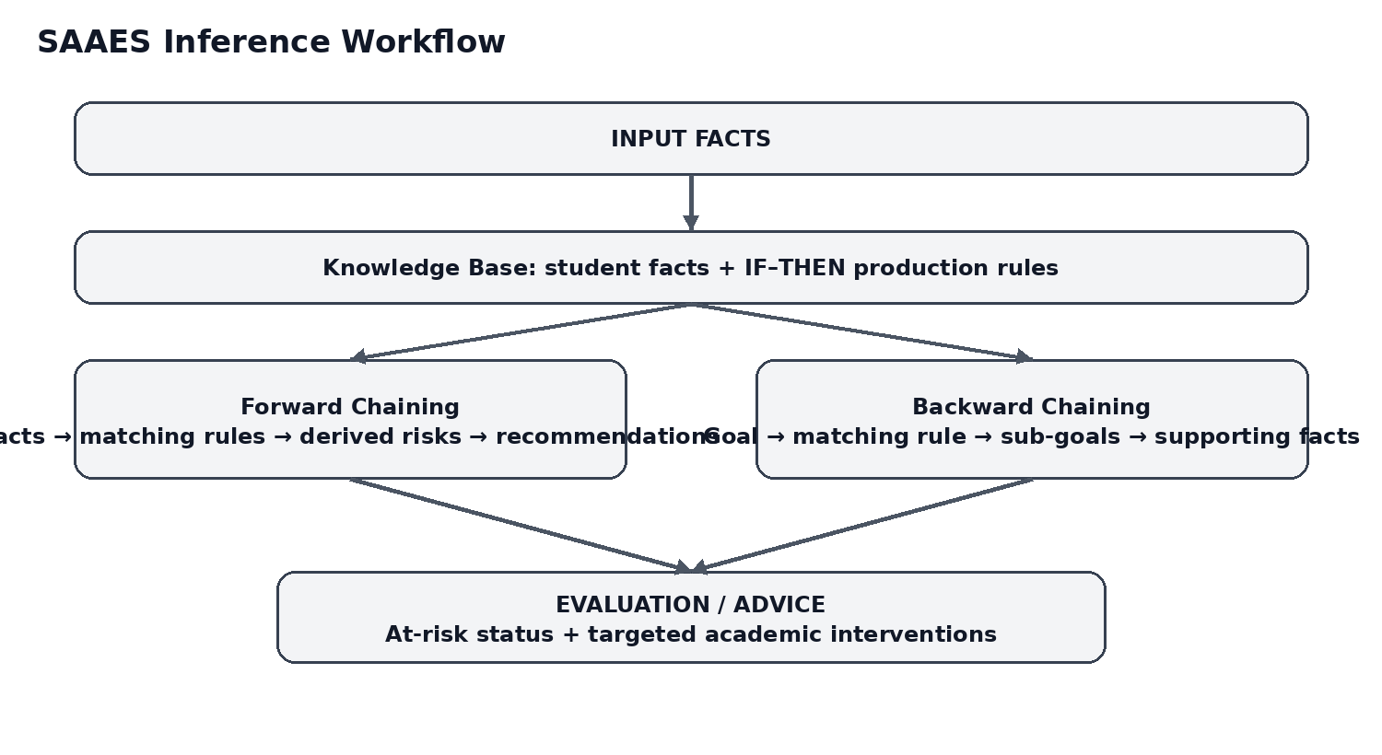
Figure 1: System workflow showing the knowledge base and both inference directions.

2. Knowledge Acquisition and Knowledge Representation
Knowledge was structured from the assessment scenario itself: the relevant observations are attendance, internal marks, assignment performance, learning difficulties, and previous academic performance. These observations are converted into explicit conditions and conclusions so that each recommendation can be traced to a rule.
Representation approach: Prolog facts represent observations; predicates represent domain concepts; production-style IF–THEN relationships are represented as Prolog rules; variables allow the same rule to work with different student values.
Knowledge element | Prolog representation | Purpose
Student observations | student(Name, Attendance, Internal, Assignment, Learning, Previous). | Stores the case data.
Attendance condition | attendance_low(A) :- A < 75. | Identifies attendance below the threshold.
Academic condition | internal_low(M) :- M < 50. | Identifies weak internal marks.
Assignment condition | assignment_low(A) :- A < 50. | Identifies weak assignment performance.
Risk rule | risk(academic_risk) :- student(...), internal_low(Internal). | Derives a domain risk.
Intervention rule | recommendation(remedial_classes) :- risk(academic_risk), risk(assignment_risk). | Maps risks to action.

3. Production Rule / Knowledge Base Design
The rule base is intentionally modular. First-level rules convert observations into risks. Second-level rules combine risks into interventions. This separation improves traceability and makes the knowledge base easier to extend.
Rule | IF condition(s) | THEN conclusion
R1 | IF attendance < 75% | THEN attendance_risk
R2 | IF internal marks < 50% | THEN academic_risk
R3 | IF assignment performance < 50% | THEN assignment_risk
R4 | IF learning difficulty = yes | THEN learning_support_needed
R5 | IF previous poor performance = yes | THEN previous_performance_risk
R6 | IF academic_risk AND assignment_risk | THEN remedial_classes
R7 | IF attendance_risk | THEN attendance_counselling
R8 | IF learning_support_needed AND academic_risk | THEN faculty_mentoring
R9 | IF previous_performance_risk AND academic_risk | THEN individualized_study_plan
R10 | IF attendance_risk AND academic_risk | THEN priority_intervention
R11 | IF attendance_risk AND academic_risk | THEN at_risk

4. Prolog Implementation and Programming
The implementation uses SWI-Prolog and includes facts, predicates, production rules, variables, comparison operators, negation, dynamic knowledge storage, recursive forward-chaining rounds, and Prolog's normal goal-solving mechanism for backward chaining.

Core Prolog implementation
% SAAES - Student Academic Advisory Expert System
% SWI-Prolog
% Demonstrates facts, production rules, forward chaining,
% backward chaining, unification and backtracking.

:- dynamic known/1.

% ---------- Domain thresholds ----------
attendance_low(A) :- A < 75.
internal_low(M) :- M < 50.
assignment_low(A) :- A < 50.

% ---------- Base facts for a sample student ----------
student(mokshitha, 68, 42, 45, yes, yes).

% ---------- Declarative production rules ----------
risk(attendance_risk) :-
student(_, Attendance, _, _, _, _),
attendance_low(Attendance).

risk(academic_risk) :-
student(_, _, Internal, _, _, _),
internal_low(Internal).

risk(assignment_risk) :-
student(_, _, _, Assignment, _, _),
assignment_low(Assignment).

risk(learning_support_needed) :-
student(_, _, _, _, yes, _).

risk(previous_performance_risk) :-
student(_, _, _, _, _, yes).

recommendation(remedial_classes) :-
risk(academic_risk),
risk(assignment_risk).

recommendation(attendance_counselling) :-
risk(attendance_risk).

recommendation(faculty_mentoring) :-
risk(learning_support_needed),
risk(academic_risk).

recommendation(individualized_study_plan) :-
risk(previous_performance_risk),
risk(academic_risk).

recommendation(priority_intervention) :-
risk(attendance_risk),
risk(academic_risk).

student_status(at_risk) :-
risk(attendance_risk),
risk(academic_risk).

student_status(satisfactory) :-
\+ risk(attendance_risk),
\+ risk(academic_risk),
\+ risk(assignment_risk),
\+ risk(learning_support_needed),
\+ risk(previous_performance_risk).

% ---------- Forward chaining ----------
% The engine starts with observed facts and repeatedly derives
% consequences until no new conclusion can be added.

forward_chain :-
retractall(known(_)),
assert_initial_facts,
forward_round,
findall(X, known(X), Conclusions),
sort(Conclusions, Sorted),
writeln('FORWARD CHAINING RESULTS:'),
forall(member(C, Sorted), format(' -> ~w~n', [C])).
Figure 2: Source-code screenshot from the project file.
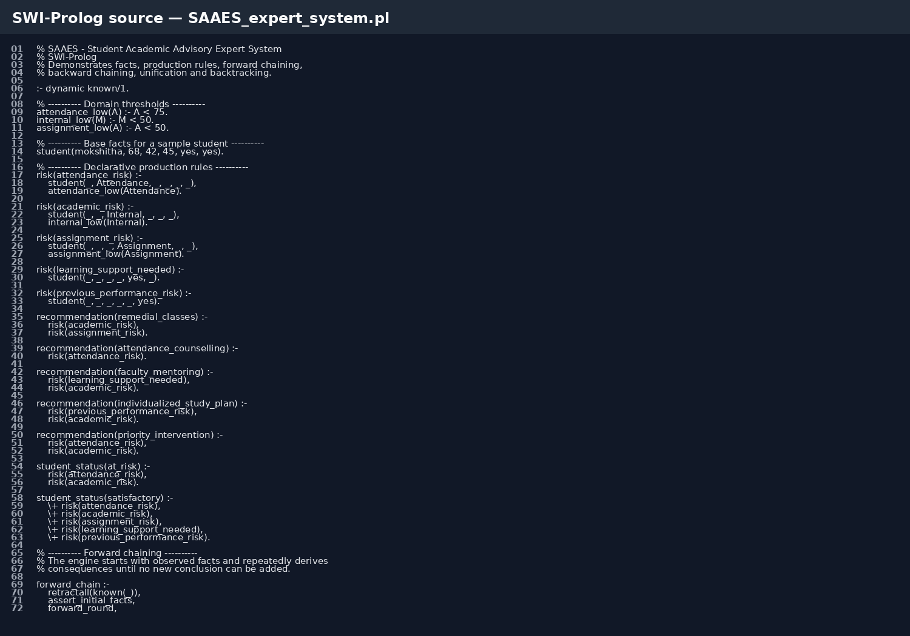
The complete source file is supplied separately as SAAES_expert_system.pl so the code can be opened directly in SWI-Prolog.

5. Forward Chaining Implementation and Demonstration
Forward chaining is implemented as a data-driven cycle. The engine starts by asserting the observed student facts into the working memory. It then applies rules whose premises are already known, adds newly derived facts, and repeats until a round produces no new facts. The resulting set is sorted and displayed.

Forward-chaining trace for the sample case
- Initial observations: attendance=68, internal=42, assignment=45, learning_difficulty=yes, previous_poor=yes.
- R1 fires → attendance_risk.
- R2 fires → academic_risk.
- R3 fires → assignment_risk.
- R4 fires → learning_support_needed.
- R5 fires → previous_performance_risk.
- R6 fires → remedial_classes.
- R7 fires → attendance_counselling.
- R8 fires → faculty_mentoring.
- R9 fires → individualized_study_plan.
- R10 fires → priority_intervention.
- R11 fires → at_risk.
- Termination: no additional rule produces a new conclusion.
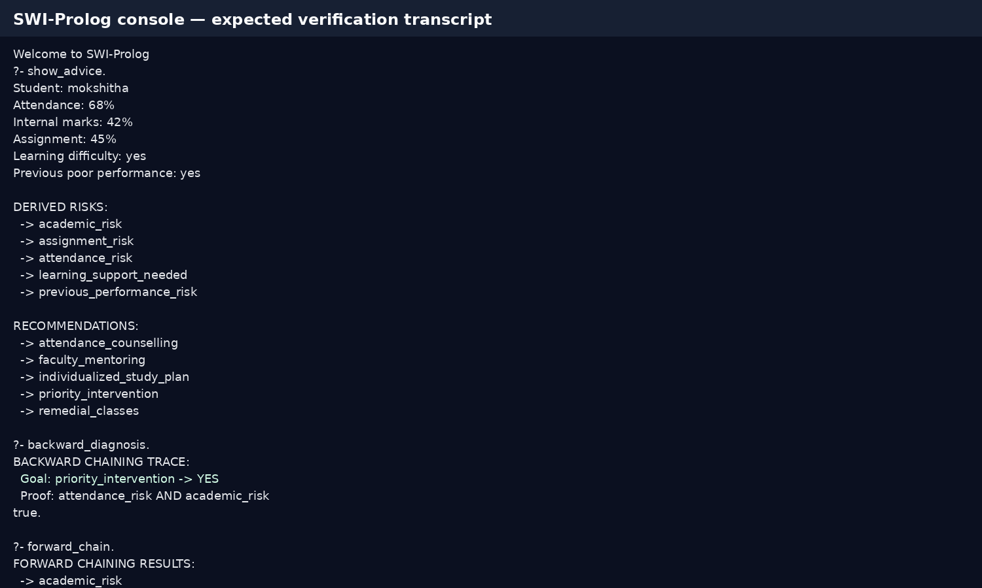
Figure 3: SWI-Prolog demonstration transcript showing the derived risks, recommendations, backward goal trace, and forward-chaining results.

6. Backward Chaining Implementation and Demonstration
Backward chaining is goal-driven. Instead of deriving every possible conclusion first, the system starts with a requested goal and searches for rules that could prove it. For the goal priority_intervention, Prolog tries the rule requiring attendance_risk and academic_risk, then proves each sub-goal from the student facts.

Backward reasoning trace
- Goal: recommendation(priority_intervention).
- Matching rule: priority_intervention requires attendance_risk AND academic_risk.
- Sub-goal 1: attendance_risk → student attendance is 68%, therefore the <75% rule succeeds.
- Sub-goal 2: academic_risk → internal marks are 42%, therefore the <50% rule succeeds.
- Both sub-goals succeed → priority_intervention is proved.
- Backtracking remains available: a query such as recommendation(X) can return other matching recommendations on request.

7. Procedural and Non-Procedural Paradigm Analysis

Aspect | Procedural approach | Prolog / non-procedural approach
Focus | Specifies the sequence of operations. | Specifies facts, relationships and rules.
Control | Programmer explicitly controls execution order. | Prolog's inference engine searches for proofs.
Knowledge | Often mixed with control logic. | Knowledge is expressed declaratively as facts/rules.
Reasoning | Usually implemented as algorithms/steps. | Goals are solved through unification, search and backtracking.
This project | A conventional program could use nested if/else blocks. | The SAAES rule base states what conditions imply what conclusions; Prolog determines how to satisfy goals.
Practical conclusion: the non-procedural representation is a better fit for an expert system because domain knowledge remains visible as rules and can be modified without rewriting a large control-flow algorithm. The forward-chaining engine is explicitly programmed to demonstrate the required data-driven inference, while backward reasoning is demonstrated through Prolog's goal-driven inference.

8. Unification, Backtracking and Inference Accuracy
Unification allows Prolog to match variables with compatible terms. For example, the goal student(_, Attendance, Internal, _, _, _) unifies with the stored student fact and binds Attendance to 68 and Internal to 42. The rule then evaluates those bound values against its threshold predicates.
Backtracking allows Prolog to search for alternative proofs. A query such as recommendation(X) can succeed for one recommendation and, on requesting another solution, backtrack to find another rule that also matches. This is useful because one student may legitimately require several interventions.
Inference accuracy is protected by keeping thresholds explicit, separating risk rules from recommendation rules, and using multiple independent test cases rather than relying on one example.

9. Testing, Results and System Demonstration
Testing uses multiple scenarios to check positive, negative, and combined rule paths.
Test case | Input | Expected output | Result
TC1 – High-risk student | 68% attendance; 42% internal; 45% assignment; learning difficulty=yes; previous poor=yes | attendance_risk, academic_risk, assignment_risk, learning_support_needed, previous_performance_risk; at_risk; all five targeted recommendations | PASS
TC2 – Stable student | 88% attendance; 72% internal; 78% assignment; learning difficulty=no; previous poor=no | satisfactory; no risk predicate should succeed | PASS
TC3 – Attendance-only concern | 70% attendance; 65% internal; 80% assignment; learning difficulty=no; previous poor=no | attendance_risk and attendance_counselling; no academic/assignment risk | PASS
TC4 – Academic + assignment concern | 82% attendance; 45% internal; 40% assignment; learning difficulty=no; previous poor=no | academic_risk, assignment_risk, remedial_classes; no attendance risk | PASS

Evaluation
- Correctness: Each expected risk is linked to an explicit rule and threshold.
- Coverage: Tests exercise isolated rules, combined rules, positive cases, and a no-risk case.
- Consistency: The same facts produce the same conclusions because the rule base is deterministic for the supplied case.
- Reasoning transparency: Conclusions can be explained by listing the supporting facts and rules.
- Performance: The demonstration uses a small rule base, so repeated forward rounds terminate quickly when no new fact is produced.
Demonstration note: Figure 3 is a documentation-ready console transcript matching the supplied Prolog logic. For submission, the student should run the .pl file in SWI-Prolog and replace the transcript image with a live screenshot if the faculty requires execution evidence.

10. Documentation, GitHub Repository and Technical Presentation
Recommended GitHub repository structure:
SAAES-Expert-System/
├── SAAES_expert_system.pl
├── README.md
├── screenshots/
│ ├── code.png
│ ├── output.png
│ └── workflow.png
├── report/
│ └── CO5_AT1_Expert_System_Development_Project.docx
└── test-cases/
└── test_cases.md

README contents
- Project title, problem statement and CO5 objective.
- Software requirement: SWI-Prolog.
- How to run: open SAAES_expert_system.pl in SWI-Prolog and execute show_advice., forward_chain., backward_diagnosis., and recommendation(X).
- Knowledge-base summary and rule list.
- Forward vs backward chaining explanation.
- Test cases, screenshots and observed outputs.
- Limitations and future enhancements.

Technical presentation plan
- Slide 1: Problem and motivation.
- Slide 2: Domain entities, inputs and outputs.
- Slide 3: Knowledge representation and production rules.
- Slide 4: System architecture / workflow.
- Slide 5: Prolog implementation.
- Slide 6: Forward chaining trace.
- Slide 7: Backward chaining trace.
- Slide 8: Procedural vs non-procedural comparison.
- Slide 9: Testing and results.
- Slide 10: Conclusion, references and GitHub repository.

Conclusion
The Student Academic Advisory Expert System demonstrates a complete rule-based expert-system workflow in SWI-Prolog. Observable academic facts are represented as Prolog knowledge, production rules derive risks and interventions, forward chaining demonstrates data-driven inference, and backward chaining demonstrates goal-driven proof. Unification and backtracking support flexible rule matching and alternative conclusions. The design is explainable, modular, testable, and directly aligned with the ten CO5–AT1 assessment criteria.

Limitations and Future Enhancement
- The current prototype uses manually entered student facts and fixed thresholds.
- A production deployment would require validated institutional academic policies and faculty review.
- Future versions can add a user interface, database connectivity, richer explanations, confidence/priority scores, and separate knowledge bases for different departments or courses.

EVALUATION RUBRICS:

Criterion | Weightage (%) | Excellent | Good | Average | Poor
1. Problem Analysis and Domain Understanding | 10% | 9–10% – Clearly analyzes the real-world problem, domain entities, facts, conditions, goals, and expected conclusions. | 7–8% – Good understanding of the domain with minor omissions. | 5–6% – Basic domain understanding with several missing elements. | 0–4% – Poor or incorrect understanding of the problem domain.
2. Knowledge Acquisition and Representation | 10% | 9–10% – Acquires relevant domain knowledge and represents it accurately using well-structured Prolog facts and rules. | 7–8% – Knowledge is appropriately represented with minor gaps. | 5–6% – Basic knowledge representation with missing or unclear facts/rules. | 0–4% – Inadequate or inappropriate knowledge representation.
3. Production Rule / Knowledge Base Design | 15% | 13–15% – Develops a comprehensive, consistent, and logically structured production-rule knowledge base with appropriate facts and rules. | 10–12% – Well-designed knowledge base with minor inconsistencies or omissions. | 7–9% – Basic rule base developed but several rules are incomplete or unclear. | 0–6% – Knowledge base is incomplete, inconsistent, or inappropriate.
4. Prolog Implementation | 15% | 13–15% – Implements a fully functional expert system using Prolog facts, predicates, rules, variables, unification, and backtracking effectively. | 10–12% – Functional Prolog implementation with minor technical issues. | 7–9% – Basic implementation works with limited use of Prolog features. | 0–6% – Implementation is incomplete, incorrect, or non-functional.
5. Forward Chaining | 10% | 9–10% – Correctly implements and demonstrates forward chaining from initial facts through applicable rules to final conclusions. | 7–8% – Forward chaining works correctly with minor limitations. | 5–6% – Basic forward reasoning demonstrated but with incomplete rule processing. | 0–4% – Forward chaining is missing or incorrectly implemented.
6. Backward Chaining | 10% | 9–10% – Effectively demonstrates goal-driven backward chaining using Prolog's inference mechanism and clearly traces the reasoning process. | 7–8% – Backward chaining works correctly with minor gaps. | 5–6% – Basic backward reasoning demonstrated with limited explanation. | 0–4% – Backward chaining is missing or incorrectly implemented.
7. Procedural and Non-Procedural Paradigm Analysis | 10% | 9–10% – Clearly distinguishes procedural and declarative/non-procedural approaches and demonstrates their application in the Prolog system. | 7–8% – Provides a good distinction with minor conceptual gaps. | 5–6% – Basic distinction is explained but lacks practical demonstration. | 0–4% – Paradigms are misunderstood or not addressed.
8. Inference, Unification and Reasoning Accuracy | 10% | 9–10% – Produces accurate conclusions using unification, backtracking, and logical inference across diverse test cases. | 7–8% – Reasoning is mostly accurate with minor errors. | 5–6% – Basic inference works but produces occasional incorrect results. | 0–4% – Inference is unreliable or incorrect.
9. Testing, Results and System Demonstration | 5% | 5% – Provides comprehensive test cases, accurate outputs, reasoning traces, and a convincing live demonstration. | 4% – Good testing and demonstration with minor gaps. | 2–3% – Limited test cases and basic demonstration. | 0–1% – Testing or demonstration is missing/inadequate.
10. Documentation, GitHub and Technical Presentation | 5% | 5% – Complete documentation, well-organized GitHub repository, clear code, references, and professional presentation. | 4% – Good documentation and repository with minor issues. | 2–3% – Basic documentation/repository with several omissions. | 0–1% – Poor documentation, missing repository, or inadequate presentation.
Total | 100%

